Standard Operating Procedure (SOP)
Deploying the AWS Baseline 3-Tier Architecture using Terraform
Document ID: CG-W1-SOP-01 | Project: CloudGuardian (CAP-CSE-3W) | Prepared by: Megha

1. Purpose
This document explains, in simple step-by-step language, how to deploy the CloudGuardian AWS baseline (secure) 3-tier architecture from scratch using Terraform on Kali Linux. Anyone with basic computer knowledge — even without prior AWS or Terraform experience — should be able to follow this document and reproduce the exact same environment.

2. Who Should Use This Document
- A team member setting up the environment for the first time.
- Anyone re-creating the environment after it was deleted/destroyed.
- An evaluator/reviewer who wants to reproduce the setup to verify the work.

3. What Gets Created
Running this SOP builds a small, realistic 3-tier web application on AWS:
- 1 VPC (Virtual Private Cloud) with 1 public subnet and 1 private subnet
- 1 Internet Gateway + Route Table (so the public subnet can reach the internet)
- 2 Security Groups (firewall rules) — one for the web server, one for the database
- 1 EC2 instance (web server) running Apache, placed in the public subnet
- 1 RDS MySQL database, placed in the private subnet (not exposed to the internet)
- 1 S3 bucket with versioning, encryption, and public access blocked
- 1 IAM Role attached to the EC2 instance with least-privilege S3 read-only access
NOTE: This is the SECURE baseline version. A separate, deliberately misconfigured version is built later for Week 3 remediation practice — that is a different SOP.

4. Prerequisites (Check Before You Start)
- A Kali Linux machine (VM or physical), logged in as the normal user 'kali' — NOT root.
- Terraform installed on Kali.
- AWS CLI installed and configured with a working AWS account/IAM user that has permission to create VPC, EC2, RDS, S3, and IAM resources.
- Internet connectivity on the Kali machine.
NOTE: Never share, paste, or save your AWS Access Key / Secret Key anywhere in chat, code comments, or public files. Keep credentials only inside 'aws configure' (stored securely on your machine).

4.1 Confirm you are the correct user
Command:
whoami
Expected result: The terminal should print: kali (if it prints 'root', switch user first with: su - kali)
[ Snapshot Space — paste screenshot here: terminal output of 'whoami' ]
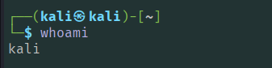

4.2 Confirm Terraform is installed
Command:
terraform -version
Expected result: A version number is printed, for example: Terraform v1.x.x
[ Snapshot Space — paste screenshot here: terminal output of 'terraform -version' ]
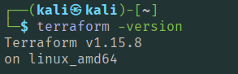

4.3 Confirm AWS CLI is configured
Command:
aws sts get-caller-identity
Expected result: A small JSON block is printed showing your AWS Account ID, User ID, and ARN. If this fails, run 'aws configure' first and enter your Access Key, Secret Key, region (ap-south-1), and output format (json).
[ Snapshot Space — paste screenshot here: terminal output of 'aws sts get-caller-identity' ]
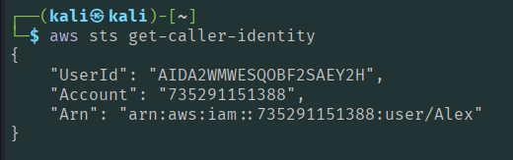

5. Step-by-Step Procedure
STEP 1: Create the Project Folder
Create a dedicated folder to hold all the Terraform files for this baseline deployment, then move into it.
Commands:
mkdir -p ~/Desktop/Cloudguardian_Capstone/1.Week1/1.\ AWS/1.baseline/1.terraform
cd ~/Desktop/Cloudguardian_Capstone/1.Week1/1.\ AWS/1.baseline/1.terraform
Expected result: The terminal prompt now shows you are inside the '1.terraform' folder (path visible in the prompt).
NOTE: Every command from Step 2 onward must be run while you are INSIDE this folder.
STEP 2: Create the Terraform Configuration Files
Create the 8 files listed below, one at a time, using the 'nano' editor. For each file: run the command shown, then copy-paste the exact content into the editor, then save and exit with Ctrl+O, Enter, Ctrl+X.
File: 1.1.1.main.tf (Provider configuration)
Command to create/open the file:
nano 1.1.1.main.tf
# ============================================================
# main.tf — Provider Configuration
# Project: CloudGuardian — CAP-CSE-3W
# Purpose: Defines required providers and AWS region
# ============================================================

terraform {
required_providers {
aws = {
source = "hashicorp/aws"
version = "~> 5.0"
}
random = {
source = "hashicorp/random"
version = "~> 3.0"
}
}
}

provider "aws" {
region = var.region
}

Code Explanation: This file tells Terraform which providers to use — the AWS provider to create cloud resources and the random provider to generate a unique bucket-name suffix — and sets the AWS region for every resource. Terraform reads this first during 'terraform init' since it defines the plugins the rest of the configuration depends on.
File: 1.1.2.vpc.tf (Network: VPC, subnets, gateway, security groups)
Command to create/open the file:
nano 1.1.2.vpc.tf
# ============================================================
# vpc.tf — Network Infrastructure
# Project : CloudGuardian — CAP-CSE-3W
# Purpose : Creates VPC, Public Subnet, Private Subnet,
# Internet Gateway, Route Table and Security Group
# ============================================================

# Main VPC — contains all resources
resource "aws_vpc" "main" {
cidr_block = "10.0.0.0/16"
enable_dns_support = true
enable_dns_hostnames = true
tags = { Name = "${var.project}-vpc"}
}

# Public Subnet — Web tier lives here (ap-south-1a)
resource "aws_subnet" "public" {
vpc_id = aws_vpc.main.id
cidr_block = "10.0.1.0/24"
map_public_ip_on_launch = true
availability_zone = "ap-south-1a"
tags = { Name = "${var.project}-public" }
}

# Private Subnet — Database lives here (ap-south-1b)
resource "aws_subnet" "private" {
vpc_id = aws_vpc.main.id
cidr_block = "10.0.2.0/24"
availability_zone = "ap-south-1b"
tags = { Name = "${var.project}-private" }
}

# Internet Gateway — allows internet access for public subnet
resource "aws_internet_gateway" "igw" {
vpc_id = aws_vpc.main.id
tags = { Name = "${var.project}-igw" }
}

# Route Table — routes internet traffic through IGW
resource "aws_route_table" "public" {
vpc_id = aws_vpc.main.id

route {
cidr_block = "0.0.0.0/0"
gateway_id = aws_internet_gateway.igw.id
}

tags = { Name = "${var.project}-public-rt" }
}

# Route Table Association — links public subnet to route table
resource "aws_route_table_association" "public" {
subnet_id = aws_subnet.public.id
route_table_id = aws_route_table.public.id
}

# Security Group — controls inbound/outbound traffic for web tier
resource "aws_security_group" "web_sg" {
name = "${var.project}-web-sg"
vpc_id = aws_vpc.main.id

# Allow HTTP traffic from anywhere
ingress {
from_port = 80
to_port = 80
protocol = "tcp"
cidr_blocks = ["0.0.0.0/0"]
}

# Allow HTTPS traffic from anywhere
ingress {
from_port = 443
to_port = 443
protocol = "tcp"
cidr_blocks = ["0.0.0.0/0"]
}

# Allow all outbound traffic
egress {
from_port = 0
to_port = 0
protocol = "-1"
cidr_blocks = ["0.0.0.0/0"]
}

tags = { Name = "${var.project}-web-sg"}
}

# RDS Security Group — only allows MySQL from web tier
resource "aws_security_group" "rds_sg" {
name = "${var.project}-rds-sg"
vpc_id = aws_vpc.main.id

# Allow MySQL only from web security group
ingress {
from_port = 3306
to_port = 3306
protocol = "tcp"
security_groups = [aws_security_group.web_sg.id]
}

# Allow all outbound traffic
egress {
from_port = 0
to_port = 0
protocol = "-1"
cidr_blocks = ["0.0.0.0/0"]
}

tags = {Name = "${var.project}-rds-sg”}
}

Code Explanation: This file builds the network layer of the 3-tier setup: a VPC, a public subnet for the web server and a private subnet for the database, an Internet Gateway with a route table so the public subnet can reach the internet, and two Security Groups. The web SG opens 80/443 to everyone, while the RDS SG only allows MySQL (3306) traffic coming from the web SG, keeping the database isolated.
File: 1.1.3.ec2.tf (Web server)
Command to create/open the file:
nano 1.1.3.ec2.tf
# ============================================================
# ec2.tf — Web Tier
# Project: CloudGuardian — CAP-CSE-3W
# Purpose: Creates EC2 instance as web server with Apache
# Baseline: IMDSv2 enforced, placed in public subnet
# ============================================================

resource "aws_instance" "web" {
ami = "ami-0f58b397bc5c1f2e8" # Amazon Linux 2 — ap-south-1
instance_type = "t3.micro"
subnet_id = aws_subnet.public.id
vpc_security_group_ids = [aws_security_group.web_sg.id]
iam_instance_profile = aws_iam_instance_profile.web_profile.name

# IMDSv2 enforced — baseline secure (prevents SSRF attacks)
metadata_options {
http_endpoint = "enabled"
http_tokens = "required" # IMDSv2 only
http_put_response_hop_limit = 1
}

# User data — installs and starts Apache web server
user_data = <<-EOF
#!/bin/bash
yum update -y
yum install -y httpd
systemctl start httpd
systemctl enable httpd
echo "<html>
<head><title>CloudGuardian</title></head>
<body>
<h1>CloudGuardian Web Server</h1>
<p>3-Tier Reference Workload — Week 1 Baseline</p>
</body>
</html>" > /var/www/html/index.html
EOF

tags = {Name = "${var.project}-web"}
}

Code Explanation: This file launches the web server on Amazon Linux 2 inside the public subnet, attaching the web security group and IAM instance profile. IMDSv2 is enforced (http_tokens = required) to block SSRF-style metadata attacks. The user_data script installs and starts Apache automatically, then writes a simple HTML page so the instance is reachable in a browser right after boot.
File: 1.1.4.rds.tf (Database)
Command to create/open the file:
nano 1.1.4.rds.tf
# ============================================================
# rds.tf — Database Tier
# Project: CloudGuardian — CAP-CSE-3W
# Purpose: Creates MySQL RDS instance in private subnet
# Baseline: encrypted, private, not publicly accessible
# ============================================================

# DB Subnet Group — RDS requires subnets in at least 2 AZs
resource "aws_db_subnet_group" "main" {
name = "${var.project}-db-subnet"
subnet_ids = [aws_subnet.public.id, aws_subnet.private.id]
tags = {Name = "${var.project}-db-subnet"}
}

# RDS MySQL Instance — Baseline secure configuration
resource "aws_db_instance" "main" {
identifier = "${var.project}-db"
engine = "mysql"
engine_version = "8.0"
instance_class = "db.t3.micro"
allocated_storage = 20
db_name = "appdb"
username = "admin"
password = var.db_password

# Network configuration — uses dedicated RDS security group
db_subnet_group_name = aws_db_subnet_group.main.name
vpc_security_group_ids = [aws_security_group.rds_sg.id]

# Baseline secure settings
storage_encrypted = true # Encryption at rest enabled
publicly_accessible = false # Not exposed to internet
skip_final_snapshot = true

tags = {Name = "${var.project}-db"}
}

Code Explanation: This file provisions the MySQL database in the private subnet, using a DB subnet group so RDS knows which subnets it may use. storage_encrypted = true keeps data encrypted at rest, and publicly_accessible = false keeps the database unreachable from the internet — it can only be reached from the web tier via the RDS security group.
File: 1.1.5.s3.tf (Storage bucket)
Command to create/open the file:
nano 1.1.5.s3.tf
# ============================================================
# s3.tf — Object Storage
# Project: CloudGuardian — CAP-CSE-3W
# Purpose: Creates S3 bucket with encryption and versioning
# Baseline: secure — public access blocked
# ============================================================

# Random suffix for globally unique bucket name
resource "random_id" "suffix" {
byte_length = 4
}

# Main S3 Bucket
resource "aws_s3_bucket" "data" {
bucket = "${var.project}-data-${random_id.suffix.hex}"
force_destroy = true
tags = {Name = "${var.project}-bucket"}
}

# Enable versioning — protects against accidental deletion
resource "aws_s3_bucket_versioning" "data" {
bucket = aws_s3_bucket.data.id
versioning_configuration {
status = "Enabled"
}
}

# Enable default encryption — data at rest is encrypted
resource "aws_s3_bucket_server_side_encryption_configuration" "data" {
bucket = aws_s3_bucket.data.id
rule {
apply_server_side_encryption_by_default {
sse_algorithm = "AES256"
}
}
}

# Block all public access — baseline secure configuration
resource "aws_s3_bucket_public_access_block" "data" {
bucket = aws_s3_bucket.data.id
block_public_acls = true
block_public_policy = true
ignore_public_acls = true
restrict_public_buckets = true
}

Code Explanation: This file creates the S3 bucket used for application data. A random suffix keeps the bucket name globally unique. Versioning protects against accidental overwrite or deletion, server-side encryption (AES256) secures data at rest, and the public access block resource explicitly disables every path to public exposure — ACLs, bucket policies, and legacy public settings.
File: 1.1.6.Iam.tf(IAM role for the web server)
Command to create/open the file:
nano 1.1.6.Iam.tf
# ============================================================
# iam.tf — Identity and Access Management
# Project: CloudGuardian — CAP-CSE-3W
# Purpose: Creates IAM role for EC2 web tier with
# least privilege S3 read-only access
# Baseline: minimal permissions only
# ============================================================

# IAM Role — allows EC2 to assume this role
resource "aws_iam_role" "web_role" {
name = "${var.project}-web-role"

# Trust policy — only EC2 can assume this role
assume_role_policy = jsonencode({
Version = "2012-10-17"
Statement = [{
Effect = "Allow"
Principal = {Service = "ec2.amazonaws.com"}
Action = "sts:AssumeRole"
}]
})

tags = {Name = "${var.project}-web-role"}
}

# IAM Policy — least privilege S3 read only
# Baseline secure: NO wildcard actions, NO admin access
resource "aws_iam_role_policy" "web_policy" {
name = "${var.project}-s3-read-only"
role = aws_iam_role.web_role.id

policy = jsonencode({
Version = "2012-10-17"
Statement = [{
Effect = "Allow"
Action = [
"s3:GetObject", # Read objects only
"s3:ListBucket" # List bucket contents only
]
Resource = [
aws_s3_bucket.data.arn,
"${aws_s3_bucket.data.arn}/*"
]
}]
})
}

# IAM Instance Profile — attaches role to EC2
resource "aws_iam_instance_profile" "web_profile" {
name = "${var.project}-web-profile"
role = aws_iam_role.web_role.name
}

Code Explanation: This file creates the IAM role the EC2 instance assumes at boot (trust policy allows only ec2.amazonaws.com), attaches a least-privilege inline policy permitting only s3:GetObject and s3:ListBucket on the one data bucket — no wildcards, no admin rights — and wraps the role in an instance profile so EC2 can actually use it.
File: 1.1.7. variables.tf (Configurable values)
Command to create/open the file:
nano "1.1.7. variables.tf"
# ============================================================
# variables.tf — All Variables for CloudGuardian Project
# Project: CloudGuardian — CAP-CSE-3W
# Purpose: Central place for all configurable values
# ============================================================

# AWS Region where all resources will be deployed
variable "region" {
default = "ap-south-1"
description = "AWS region for deployment"
}

# Project name — used as prefix for all resource names
variable "project" {
default = "cloudguardian"
description = "Project name prefix"
}

# RDS Database password
variable "db_password" {
default = "TempPass123!"
description = "RDS master password"
sensitive = true
}

NOTE: The default database password in this file (TempPass123!) is a placeholder used for a training/lab environment only. For any real deployment, change it to a strong unique password before running terraform apply.
Code Explanation: This file centralizes every configurable value so nothing is hardcoded elsewhere — the AWS region, the project name prefix used in all resource names, and the RDS master password, marked sensitive so Terraform won't print it in logs or plan output.
File: 1.1.8. outputs.tf (What gets printed after deployment)
Command to create/open the file:
nano 1.1.8. outputs.tf
# ============================================================
# outputs.tf — Output Values
# Project: CloudGuardian — CAP-CSE-3W
# Purpose: Prints important resource information after
# Terraform apply completes successfully
# ============================================================

# VPC ID
output "vpc_id" {
description = "ID of the main VPC"
value = aws_vpc.main.id
}

# Public Subnet ID
output "public_subnet_id" {
description = "ID of the public subnet (web tier)"
value = aws_subnet.public.id
}

# Private Subnet ID
output "private_subnet_id" {
description = "ID of the private subnet (database tier)"
value = aws_subnet.private.id
}

# EC2 Public IP — open this in browser to see Apache page
output "web_public_ip" {
description = "Public IP of the web server — open in browser"
value = aws_instance.web.public_ip
}

# S3 Bucket Name
output "s3_bucket_name" {
description = "Name of the S3 data bucket"
value = aws_s3_bucket.data.bucket
}

# RDS Endpoint
output "rds_endpoint" {
description = "RDS MySQL endpoint"
value = aws_db_instance.main.endpoint
}

# Security Group IDs
output "web_security_group_id" {
description = "ID of the web security group"
value = aws_security_group.web_sg.id
}

output "rds_security_group_id" {
description = "ID of the RDS security group"
value = aws_security_group.rds_sg.id
}

Code Explanation: This file defines what Terraform prints after a successful apply — VPC and subnet IDs, the web server's public IP (to open in a browser), the S3 bucket name, the RDS endpoint, and both security group IDs. These outputs are later saved to baseline_outputs.txt for use in the Week 2/3 scanning steps.
STEP 3: Verify All 8 Files Are Present
Command:

ls -la
Expected result: You should see all 8 .tf files listed (1.1.1.main.tf through 1.1.8.outputs.tf).
[ Snapshot Space — paste screenshot here: terminal output of 'ls -la' showing all 8 .tf files ]
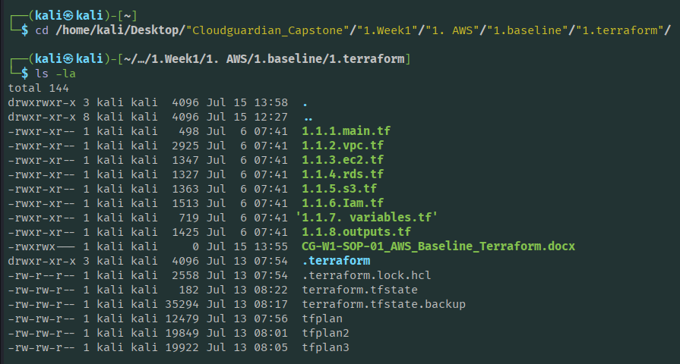
STEP 4: Initialize Terraform
This downloads the AWS and random providers Terraform needs, and prepares the working directory.
Command:
terraform init
Expected result: Message at the end: 'Terraform has been successfully initialized!'
[ Snapshot Space — paste screenshot here: terminal output of 'terraform init' success message ]
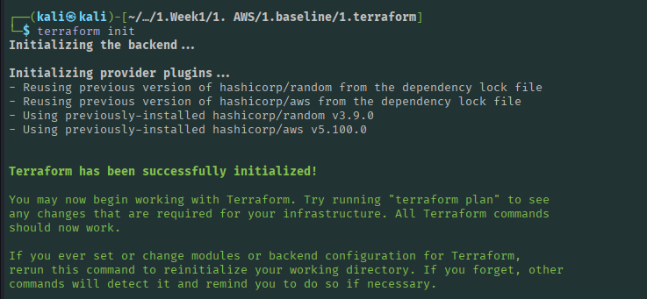
STEP 5: Validate the Configuration
This checks the files for syntax errors before touching AWS.
Command:
terraform validate
Expected result: Message: 'Success! The configuration is valid.'
[ Snapshot Space — paste screenshot here: terminal output of 'terraform validate' success message ]
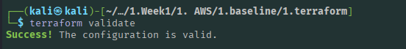
STEP 6: Preview the Plan (dry run — nothing is created yet)
Command:
terraform plan
Expected result: A detailed list of resources Terraform WILL create, ending with a line like: 'Plan: 15 to add, 0 to change, 0 to destroy.' Read this carefully before continuing.
[ Snapshot Space — paste screenshot here: terminal output of 'terraform plan' summary line ]
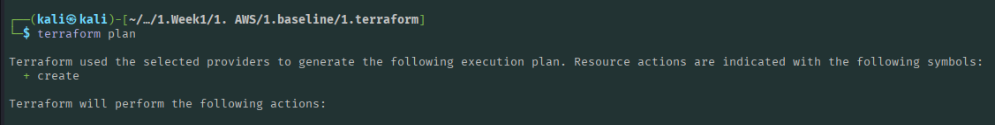
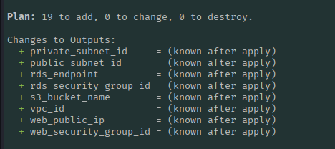
STEP 7: Apply — Actually Create the Resources on AWS
Command:
terraform apply
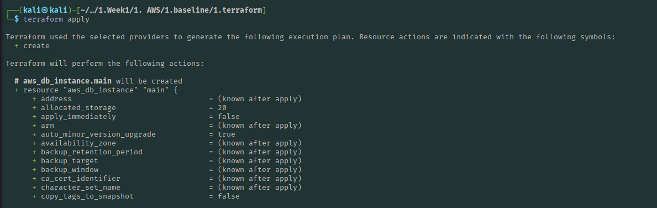
NOTE: Terraform will show the same plan again and then ask: 'Do you want to perform these actions? Enter a value:' — type yes and press Enter.
When prompted, type:
yes
Expected result: Terraform creates each resource one by one (this takes a few minutes, mainly because of the RDS database). At the end it prints 'Apply complete!' followed by the Outputs block (VPC ID, public IP, S3 bucket name, RDS endpoint, etc.).
[ Snapshot Space — paste screenshot here: terminal output of 'terraform apply' completing with Outputs block ]
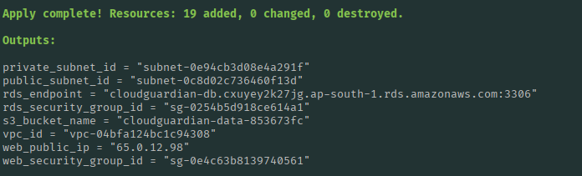

STEP 8: Verify the Deployment
8a. Check the web server is live — copy the 'web_public_ip' value from the output above and open it in a browser:
In your browser address bar, type:
http://<web_public_ip>
http//65.0.12.98
Expected result: A simple page loads showing: 'CloudGuardian Web Server — 3-Tier Reference Workload — Week 1 Baseline'.
[ Snapshot Space — paste screenshot here: browser screenshot of the CloudGuardian web page ]
8b. Confirm resources from the Kali terminal using AWS CLI:
Command:
aws ec2 describe-instances --region ap-south-1 --query "Reservations[].Instances[].State.Name"
Expected result: Prints ["running"] — the EC2 instance is up.
[ Snapshot Space — paste screenshot here: terminal output of EC2 instance state = running ]
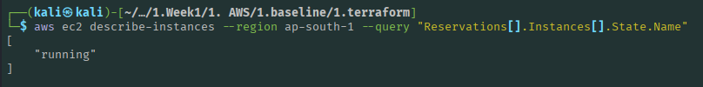
Command:
aws rds describe-db-instances --region ap-south-1 --query "DBInstances[].DBInstanceStatus"
Expected result: Prints ["available"] once the database has finished creating.
[ Snapshot Space — paste screenshot here: terminal output of RDS instance status = available ]
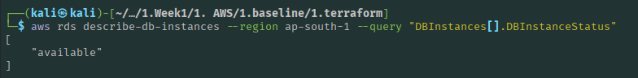
Command:
aws s3 ls | grep cloudguardian
Expected result: Prints the S3 bucket name (e.g. cloudguardian-data-xxxxxxxx).
[ Snapshot Space — paste screenshot here: terminal output of 'aws s3 ls' showing the bucket ]
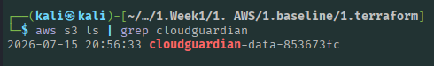
STEP 9: Save the Outputs for Later Steps
Save the full output block to a text file — later SOPs (Prowler / ScoutSuite / Steampipe scans) need this information.
Command:
terraform output > baseline_outputs.txt
Expected result: A new file 'baseline_outputs.txt' appears in the folder containing all the output values.
[ Snapshot Space — paste screenshot here: contents/listing of baseline_outputs.txt ]
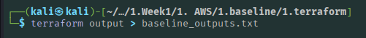
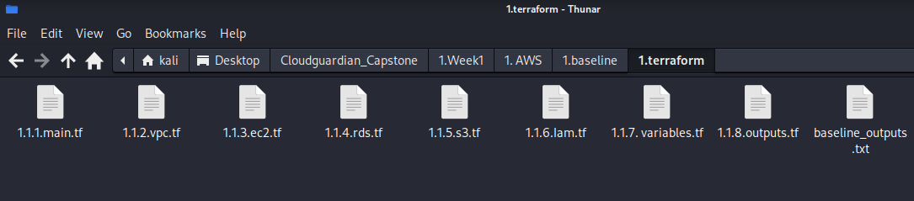
Link - baseline_outputs.txt

6. Cleaning Up (Only When You Are Completely Done)
NOTE: Do NOT run this until you have finished all scans/screenshots for this baseline — this permanently deletes every resource created above.
Command:
terraform destroy
When prompted, type:
Yes
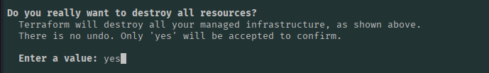
Expected result: Terraform removes all resources one by one and finally prints 'Destroy complete!'.
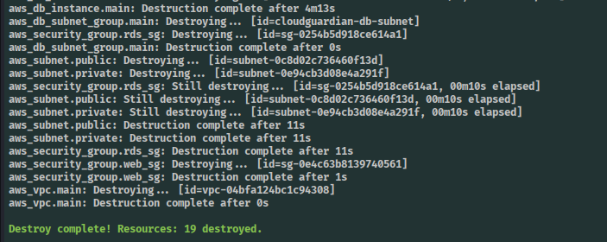

7. Troubleshooting Quick Reference
- 'Error: InvalidClientTokenId' → AWS CLI is not configured correctly. Run 'aws configure' again.
- 'terraform: command not found' → Terraform is not installed or not in PATH.
- Stuck at IAM/permission errors → the AWS IAM user does not have enough permissions; ask the account owner to grant them.
- Wrong region resources → double-check the 'region' variable in 1.1.7. variables.tf is 'ap-south-1'.

8. Document Control
- Document ID: CG-W1-SOP-01
- Applies to: CloudGuardian Capstone, Week 1 — AWS Baseline (secure) architecture
- Related SOPs: CG-W1-SOP-02 (Misconfigured baseline), CG-W3-SOP-01 to 04 (Remediation)

